**Final Lab Project 2025**

**Student Name : _________赵云昊_____________________**

**Student No. : ______________1220025803________________**

**Topology**

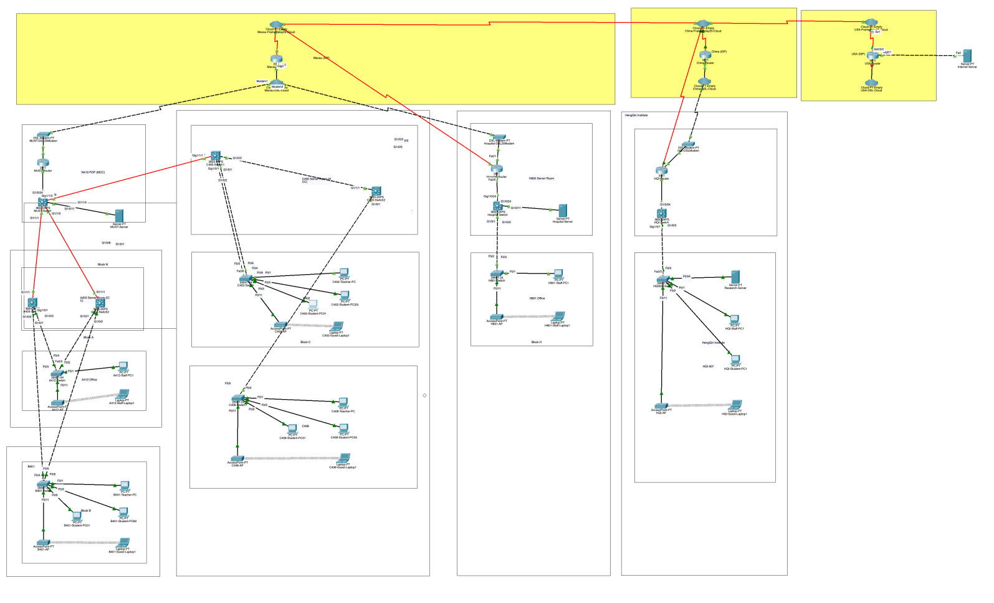

**Note:** Please replace above incomplete topology with your complete topology when submitted.

**Important** **Note:** Please configure the .pkt file using the Cisco Packet Tracer version 8.2.2.

**Device**

**Macau:** (Public address: 200.0.0.0/8)

**MUST:** (Private address: XX.0.0.0/8) (Public address: 200.200.200.2~6/28)

Note: Please replace the first octet of above private subnet XX.0.0.0/8 with the last two digits of your student no., 17098530-I011-00XX. (Note: only if XX = 01 or 00, use XX =10.) 3.0.0.0/8

**Block ABC:**

**Block A:** (Subnet: XX.1.0.0/16) 3.1.0.0/16

Faculty Office:

A412: 1 Staff-PC, 1 Staff-Laptop

Server room:

A403: some Routers and Switches

**Block B:** (Subnet: XX.2.0.0/16) 3.2.0.0/16

Class room:

B401: 1 Teacher-PC, 80 Student-PC, 1 Guest-Laptop

**Block C:** (Subnet: XX.3.0.0/16) 3.3.0.0/16

Laboratory:

C402: 1 Teacher-PC, 20 Student-PC, 1 Guest-Laptop

C408: 1 Teacher-PC, 55 Student-PC, 1 Guest-Laptop

Server room:

C400: some Routers and Switches

**Block H:** (Subnet: XX.8.0.0/16) 3.8.0.0/16

Staff Office:

H801: 1 Staff -PC, 1 Staff-Laptop

Server room:

H800: Hospital-Server (Domain Name: server.uh.org.mo), some Routers and Switches

**Block N:** (Subnet: XX.14.0.0/16) 3.14.0.0/16

Server room (POP):

N418: MUST-Server (Domain Name: server.must.edu.mo), some Routers and Switches

**China:** (Public address: 100.0.0.0/8)

**HengQin Institute:** (Subnet: XX.27.0.0/16) (Public address: 100.100.100.2/30) 3.27.0.0/16

HQI-307: 1 Staff-PC, 1 Student-PC, 1 Guest-Laptop, Research-Server (Domain Name: research.must.edu.mo)

**USA:** (Public address: 1.0.0.0/8)

**Internet:** (Subnet: 1.0.0.0/8)

Internet:

1 Internet-Server (IP: 1.2.3.4/8) (Domain Name: server.internet.net)

**Address**

|  |  |  |  |
| --- | --- | --- | --- |
| Host name | Interface | IPv4/IPv6 address | Memo |
| A403-Switch1 | G1/0/1~G1/0/3 |  | trunk |
| VLAN 99、77 |  |  |
| VLAN 11、22、88 |  |  |
| VLAN |  |  |
| A403-Switch2 | G1/0/3 |  | trunk |
| G1/0/2 |  | trunk |
| G1/0/1 |  | trunk |
|  |  |  |
| B401-Switch | F0/1 |  | VLAN11 teacherB |
| F0/2 ~ F0/3 |  | VLAN22 studentB |
| F0/4~F0/5 |  | trunk |
| F0/11 |  | VLAN88 guestB |
| A412-Switch | F0/1 |  | VLAN99 staff |
| F0/11 |  | VLAN77 guest-staff |
| F0/2 ~ F0/3 |  | trunk |
| F0/4 |  | trunk |
| F0/5 |  | trunk |
| C402-Switch | F0/2 ～F0/3 |  | VLAN23 studentC |
| F0/1 |  | VLAN12 teacherC |
| F0/11 |  | VLAN89 guestC |
| F0/5~F0/6 |  | trunk |
| F0/4 |  | trunk |
| C408-Switch1 | F0/1 |  | VLAN12 teacherC |
| F0/2~F0/3 |  | VLAN23 studentC |
| F0/11 |  | VLAN89 guestC |
| F0/4 |  | trunk |
| F0/5~F0/7 |  | trunk |
| C400-Switch1 | G1/0/1-5 |  | trunk |
| VLAN12 |  |  |
| VLAN23 |  |  |
| VLAN89 |  |  |
| C400-Switch2 | G1/0/3 |  | trunk |
| G1/0/1 |  | trunk |
| G1/0/2 &G1/0/4 |  | trunk |
| VLAN12 |  |  |
| VLAN23 |  |  |
| VLAN89 |  |  |
| MUST-Switch | G1/1/1 | 3.14.1.2/30 | trunk |
| G1/1/2 | 3.14.1.1/30 | trunk |
| G1/0/3 |  | trunk |
| G1/0/4 |  | trunk |
| G1/0/11 | 3.14.100.1/24 | VLAN100 must-server |
| G1/0/24 | 3.14.199.1/24 |  |
|  |  |  |
|  |  |  |
|  |  |  |
|  |  |  |
| Hospital-Switch | G1/0/24 | 3.8.199.1/24 |  |
| G/0/11 |  | VLAN113 Hospital-server |
| G1/0/1 |  | trunk |
| H801-Switch | F0/2 |  | trunk |
| F0/1 |  | VLAN 111 Hospital-staff |
| F0/11 |  | VLAN 112 Hospital-Guest-staff |
| HQI-Switch | G1/0/1 | vlan 55(3.27.55.1)  vlan 56(3.27.56.1)  vlan 57(3.27.57.1)  vlan 58(3.27.58.1) | trunk |
| G1/0/24 | 3.27.199.1/24 |  |
| HQI308-witch | F0/3 |  | trunk |
| F0/24 |  | VLAN 55 Research-Server |
| F0/1 |  | VLAN 56 HQI-staff |
| F0/2 |  | VLAN 57 HQI-student |
| F0/11 |  | VLAN 58 HQI-Guest |
| TeacherPC in B | F0 | 3.2.11.4/29 | VLAN 11 |
| StudentPC01-80 in B | F0 | 3.2.22.3/25(3.2.22.2-3.2.22.126) | VLAN 22 |
| GuestLaptop in B | F0 | 3.2.88.0/24 (3.2.88.3-3.2.88.254) | VLAN 88 |
| TeacherPC in C402 | F0 | 3.3.12.0/29（3.3.12.2-3.3.12.6） | VLAN 12 |
| TeachrerPC in C408 | F0 | 3.3.12.0/29（3.3.12.2-3.3.12.6） | VLAN 12 |
| StudentPC01~55 in C408 | F0 | 3.3.23.0/25(3.3.23.2-3.3.23.58) | VLAN 23 |
| StudentPC01~20 in C402 | F0 | 3.3.23.0/25(3.3.23.59-3.3.23.126) | VLAN 23 |
| GuestLaptop in C | F0 | 3.3.89.0/24(3.3.89.3-3.3.89.254) | VLAN 89 |
| Staff-PC in A | F0 | 3.1.0.3/16 | 99 |
| GuestStaff in A | F0 | 3.1.10.3/24 | 77 |
| Staff-PC in H | F0 | 3.8.0.1/16 |  |
| Staff-laptop in H | F0 | 3.8.0.2/16 |  |
| Hospital Server | F0 | 3.27.55.2/24 |  |
| HQI-StaffPC | F0 | 3.27.56.2/24 |  |
| HQI-StudentPC | F0 | 3.27.57.2/24 |  |
| HQI-GuestLaptop | F0 | 3.27.58.2/24 |  |
| Research Server | F0 | 3.27.0.4/16 |  |
| MUST Router | F0 | 3.14.199.2/24 |  |
| Hospital Router | F0 | 3.8.199.2/24 |  |
| HQI-Router | F0/0 | 3.27.199.2/24 |  |
| F0/1 | 100.100.50.2/24 |  |
| Serial0/0/0.3 | 200.202.0.9/16 |  |
| Macau-Router | G0/0 | 200.200.100.3/29 |  |
| Serial0/0/.1 | 200.201.0.2/16 |  |
| Serial0/0.3 | 200.202.0.6/16 |  |
| China-Router | G0/0 | 100.100.50.3/24 |  |
| Serial0/0/0.3 | 200.202.0.3/16 |  |
| USA-Router | G0/1 | 1.2.3.1/8 |  |
| Serial0/0/0.2 | 200.201.0.5/16 |  |
| MUST-Router | F0/0 | 3.14.199.2/24 |  |
| F0/1 | 200.200.100.2/29 |  |
| Hospital-Router | F0/0 | 3.8.199.2/24 |  |
| F0/1 | 200.200.100.4/29 |  |

**Translation:**

|  |  |  |
| --- | --- | --- |
| Address Scheme for NAT | | |
|  | Public IPv4 addresses | Private IPv4 addresses |
| MUST-Router | 200.200.200.3～4/28 | 3.1.0.0/16  3.2.0.0/16 |
| Hospital-Router | 200.200.200.5-200.200.200.6/28 | 3.8.0.0/16 |
| HQI-Router | 100.100.100.2/30 | 3.27.0.0/16 |
| MUST-Router | 200.200.200.2/28(MUST server exclusive) | 3.14.100.2 |
|  |  |  |

**Requirement (80%)**

**Task 1 - Internet Access** **(50 %)**

* All PCs and Laptops, including the Staff-PC/Teacher-PC/Student-PC/Guest-Laptop, can access all services of the Internet-Server.

|  |  |  |
| --- | --- | --- |
|  | Testing | Success/Failure |
| 1.1 | All: A412-Staff-PC -> Internet-Server | Y |
| 1.2 | All: B401-Teacher-PC -> Internet-Server | Y |
| 1.3 | All: C402-Student-PC -> Internet-Server | Y |
| 1.4 | All: C408-Guest-Laptop -> Internet-Server | Y |

**Task 2 - Server Access (15 %)**

* All campus PCs and Laptops, including the Staff-PC/Teacher-PC/Student-PC, can ping all campus servers, including MUST-Server/Hospital-Server/Research-Server **using private address** (XX.0.0.0/8). The Guest-Laptop cannot ping any campus server.
* The Internet-Server can access **only** the web service of two campus servers, including MUST-Server/Hospital-Server, using HTTP (port:80) and HTTPS (port:443), and cannot access any services of Research-Server.
* The Teacher-PCs can access all services of Research-Server, but the Student-PCs can access **only** the web service of Research-Server using HTTP and HTTPS.

|  |  |  |
| --- | --- | --- |
|  | Testing | Success/Failure |
| 2.1 | Ping: A412-Staff-PC/B401-Teacher-PC/C402-Student-PC -> MUST-Server | Y |
| 2.2 | Ping: A412-Staff-PC/B401-Teacher-PC/C402-Student-PC -> Hospital-Server (ping 3.8.113.2) | Y |
| 2.3 | Ping: A412-Staff-PC/B401-Teacher-PC/C402-Student-PC -> Research-Server | Y |
| 2.4 | cannot Ping: C408-Guest-Laptop -> MUST-Server/Hospital-Server/Research-Server | Y |
| 2.5 | HTTP/HTTPS: Internet-Server -> MUST-Server (200.200.200.2) | Y |
| 2.6 | HTTP/HTTPS: Internet-Server -> Hospital-Server (3.8.113.2) | Y |
| 2.7 | cannot All: Internet-Server -> Research-Server (ping 100.100.100.2 unreachable) | Y |
| 2.8 | All: B401-Teacher-PC -> Research-Server | Y |
| 2.9 | HTTP/HTTPS: C402-Student-PC -> Research-Server(3.27.55.2) | Y |
| 2.10 | cannot Other: C402-Student-PC -> Research-Server | Y? |

**Task 3 - Router Access** **(15 %)**

* Only the users (e.g. Username: Admin-User/Password: Hello) from the Staff-PCs, including A412-Staff/Hospital-Staff/HQI-Staff, can login (SSH) to three campus routers **using private address** (XX.0.0.0/8), including MUST-Router/Hospital-Router/HQI-Router, after authenticated by the RADIUS server of MUST-Server.

|  |  |  |
| --- | --- | --- |
|  | Testing | Success/Failure |
| 3.1 | Login: A412-Staff -> MUST-Router | Y |
| 3.2 | Login: H801-Staff -> Hospital-Router | Y |
| 3.3 | Login: HQI-Staff -> HQI-Router | Y |
| 3.4 | cannot Login: B401-Teacher-PC/C402-Student-PC/C408-Guest-Laptop -> HQI-Router | N |

**~~Task 4 - … (… %)~~**

* ~~DNS~~

**Configuration (20 %)**

**1. Switched LAN (2%)**

//STP

A403-Switch1(config)#**spanning-tree vlan 99 priority 4096**

A403-Switch1(config)#**spanning-tree vlan 77 priority 4096**

A403-Switch1(config)#**spanning-tree vlan 88 priority 8192**

A403-Switch1(config)#**spanning-tree vlan 11 priority 8192**

A403-Switch1(config)#**spanning-tree vlan 22 priority 8192**

**2. Virtual LAN (4%)**

//VTP

Switch(config)#

Switch#show interfaces trunk

Port Mode Encapsulation Status Native vlan

Fa0/4 on 802.1q trunking 1

Fa0/5 on 802.1q trunking 1

Switch#show interfaces trunk

Port Mode Encapsulation Status Native vlan

Fa0/2 on 802.1q trunking 1

Fa0/3 on 802.1q trunking 1

Port Vlans allowed on trunk

Fa0/2 1-1005

Fa0/3 1-1005

Port Vlans allowed and active in management domain

Fa0/2 1,11,12,22,23,77,88,89,99,100

Fa0/3 1,11,12,22,23,77,88,89,99,100

Port Vlans in spanning tree forwarding state and not pruned

Fa0/2 1,11,12,22,23,77,88,89,99,100

//Intra-VLAN

Switch(config)#

//Inter-VLAN

Switch(config)#

//Gateway Redundancy

Switch(config)#

// Link Redundancy

Switch(config)#

//C402-switch

Switch#show vlan

VLAN Name Status Ports

---- -------------------------------- --------- -------------------------------

1 default active Fa0/10, Fa0/12, Fa0/13, Fa0/14

Fa0/15, Fa0/16, Fa0/17, Fa0/18

Fa0/19, Fa0/20, Fa0/21, Fa0/22

Fa0/23, Fa0/24, Gig0/1, Gig0/2

11 teacherB active

12 teacherC active Fa0/1

22 studentB active

23 studentC active Fa0/2, Fa0/3

77 guest-staff active

88 guestB active

89 guestC active Fa0/11

99 staff active

100 must-server active

1002 fddi-default active

1003 token-ring-default active

1004 fddinet-default active

1005 trnet-default active

//C408-switch1

Switch#show vlan

VLAN Name Status Ports

---- -------------------------------- --------- -------------------------------

1 default active Fa0/6, Fa0/7, Fa0/8, Fa0/9

Fa0/10, Fa0/12, Fa0/13, Fa0/14

Fa0/15, Fa0/16, Fa0/17, Fa0/18

Fa0/19, Fa0/20, Fa0/21, Fa0/22

Fa0/23, Fa0/24, Gig0/1, Gig0/2

11 teacherB active

12 teacherC active Fa0/1

22 studentB active

23 studentC active Fa0/2, Fa0/3

77 guest-staff active

88 guestB active

89 guestC active Fa0/11

99 staff active

100 must-server active

1002 fddi-default active

1003 token-ring-default active

1004 fddinet-default active

1005 trnet-default active

HQI308-Switch#show vlan

VLAN Name Status Ports

---- -------------------------------- --------- -------------------------------

1 default active Fa0/5, Fa0/6, Fa0/7, Fa0/8

Fa0/9, Fa0/10, Fa0/12, Fa0/13

Fa0/14, Fa0/15, Fa0/16, Fa0/17

Fa0/18, Fa0/19, Fa0/20, Fa0/21

Fa0/22, Fa0/23, Gig0/1, Gig0/2

55 Research-Server active Fa0/24

56 HQI-staff active Fa0/1

57 HQI-student active Fa0/2

58 HQI-GUEST active Fa0/11

59 VLAN0059 active

1002 fddi-default active

1003 token-ring-default active

1004 fddinet-default active

1005 trnet-default active

// Link Redundancy

Switch(config)#

C400-Switch1(config)#interface range gigabitEthernet 1/0/1-2

C400-Switch1(config-if-range)#cahnnel-protocol lacp

^

% Invalid input detected at '^' marker.

C400-Switch1(config-if-range)#channel-pro

C400-Switch1(config-if-range)#channel-protocol lac

C400-Switch1(config-if-range)#channel-protocol lacp

C400-Switch1(config-if-range)#chennel-grounp 5 mode active

^

% Invalid input detected at '^' marker.

C400-Switch1(config-if-range)#channel-grounp 5 mode active

^

% Invalid input detected at '^' marker.

C400-Switch1(config-if-range)#channel-group 5 mode active

C400-Switch1(config-if-range)#

Creating a port-channel interface Port-channel 5

%LINEPROTO-5-UPDOWN: Line protocol on Interface GigabitEthernet1/0/1, changed state to down

%LINEPROTO-5-UPDOWN: Line protocol on Interface GigabitEthernet1/0/1, changed state to up

%LINEPROTO-5-UPDOWN: Line protocol on Interface GigabitEthernet1/0/2, changed state to down

%LINEPROTO-5-UPDOWN: Line protocol on Interface GigabitEthernet1/0/2, changed state to up

%LINK-5-CHANGED: Interface Port-channel5, changed state to up

%LINEPROTO-5-UPDOWN: Line protocol on Interface Port-channel5, changed state to up

Switch(config)#

Switch(config)#inter

Switch(config)#interface range f

Switch(config)#interface range fastEthernet 0/5-6

Switch(config-if-range)#channel

Switch(config-if-range)#channel-pro

Switch(config-if-range)#channel-protocol lacp

Switch(config-if-range)#channel-group 5 mode active

Switch(config-if-range)#

Creating a port-channel interface Port-channel 5

%LINEPROTO-5-UPDOWN: Line protocol on Interface FastEthernet0/5, changed state to down

%LINEPROTO-5-UPDOWN: Line protocol on Interface FastEthernet0/5, changed state to up

%LINEPROTO-5-UPDOWN: Line protocol on Interface FastEthernet0/6, changed state to down

%LINEPROTO-5-UPDOWN: Line protocol on Interface FastEthernet0/6, changed state to up

%LINK-5-CHANGED: Interface Port-channel5, changed state to up

%LINEPROTO-5-UPDOWN: Line protocol on Interface Port-channel5, changed state to up

//Gateway Redundancy

Switch(config)#

A403-Switch2#show standby brief

P indicates configured to preempt.

|

Interface Grp Pri P State Active Standby Virtual IP

Vl99 99 102 P Active local 3.1.0.1 3.1.0.254

Vl77 77 99 P Active local 3.1.10.2 3.1.10.254

Vl11 11 101 Active local 3.2.11.2 3.2.11.6

Vl22 22 102 P Active local 3.2.22.1 3.2.22.63

Vl88 88 102 P Active local 3.2.88.2 3.2.88.254

A403-Switch1#show standby brief

P indicates configured to preempt.

|

Interface Grp Pri P State Active Standby Virtual IP

Vl99 99 101 P Standby 3.1.0.2 local 3.1.0.254

Vl77 77 98 Standby 3.1.10.1 local 3.1.10.254

Vl88 88 101 Standby 3.2.88.2 local 3.2.88.254

Vl11 11 99 P Standby 3.2.11.1 local 3.2.11.6

Vl22 22 101 P Standby 3.2.22.2 local 3.2.22.63

// STP

A403-Switch2(config)#spanning-tree vlan 22 prio

A403-Switch2(config)#spanning-tree vlan 22 priority 4096

A403-Switch2(config)#spanning-tree vlan 88 priority 4096

A403-Switch2(config)#spanning-tree vlan 99 priority 4096

A403-Switch2(config)#spanning-tree vlan 11 priority 4096

A403-Switch2(config)#spanning-tree vlan 77 priority 4096

A403-Switch2(config)#end

A403-Switch2#

%SYS-5-CONFIG_I: Configured from console by console

A403-Switch2#show span

A403-Switch2#show spanning-tree vlan 22

VLAN0022

Spanning tree enabled protocol ieee

Root ID Priority 4118

Address 0001.4360.DB4C

This bridge is the root

Hello Time 2 sec Max Age 20 sec Forward Delay 15 sec

Bridge ID Priority 4118 (priority 4096 sys-id-ext 22)

Address 0001.4360.DB4C

Hello Time 2 sec Max Age 20 sec Forward Delay 15 sec

Aging Time 20

Interface Role Sts Cost Prio.Nbr Type

---------------- ---- --- --------- -------- --------------------------------

Gi1/0/1 Desg FWD 19 128.1 P2p

Gi1/0/2 Desg FWD 19 128.2 P2p

Gi1/0/3 Desg FWD 19 128.3 P2p

Gi1/1/1 Desg FWD 4 128.25 Shr

A403-Switch1(config)#spanning-tree vlan 22 priority 8192

A403-Switch1(config)#spanning-tree vlan 88 priority 8192

A403-Switch1(config)#spanning-tree vlan 99 priority 8192

A403-Switch1(config)#spanning-tree vlan 11 priority 8192

A403-Switch1(config)#spanning-tree vlan 77 priority 8192

//VTP

Switch(config)#

//Intra-VLAN

Switch(config)#

//B401-student-PC80 to student-PC1  
C:\>ping 3.2.22.3

Pinging 3.2.22.3 with 32 bytes of data:

Reply from 3.2.22.3: bytes=32 time<1ms TTL=128

Reply from 3.2.22.3: bytes=32 time<1ms TTL=128

Reply from 3.2.22.3: bytes=32 time<1ms TTL=128

Reply from 3.2.22.3: bytes=32 time=7ms TTL=128

Ping statistics for 3.2.22.3:

Packets: Sent = 4, Received = 4, Lost = 0 (0% loss),

Approximate round trip times in milli-seconds:

Minimum = 0ms, Maximum = 7ms, Average = 1ms

//Inter-VLAN  
/B401-student-PC80 to A412-Staff-PC1  
C:\>ping 3.1.0.3

Pinging 3.1.0.3 with 32 bytes of data:

Reply from 3.1.0.3: bytes=32 time<1ms TTL=127

Reply from 3.1.0.3: bytes=32 time<1ms TTL=127

Reply from 3.1.0.3: bytes=32 time<1ms TTL=127

Reply from 3.1.0.3: bytes=32 time<1ms TTL=127

Ping statistics for 3.1.0.3:

Packets: Sent = 4, Received = 4, Lost = 0 (0% loss),

Approximate round trip times in milli-seconds:

Minimum = 0ms, Maximum = 0ms, Average = 0ms

//A412-Staff-PC1 to B401-student-PC80

C:\>ping 3.2.22.4

Pinging 3.2.22.4 with 32 bytes of data:

Reply from 3.2.22.4: bytes=32 time<1ms TTL=127

Reply from 3.2.22.4: bytes=32 time<1ms TTL=127

Reply from 3.2.22.4: bytes=32 time<1ms TTL=127

Reply from 3.2.22.4: bytes=32 time<1ms TTL=127

Ping statistics for 3.2.22.4:

Packets: Sent = 4, Received = 4, Lost = 0 (0% loss),

Approximate round trip times in milli-seconds:

Minimum = 0ms, Maximum = 0ms, Average = 0ms

1. **Wireless LAN (2%)**

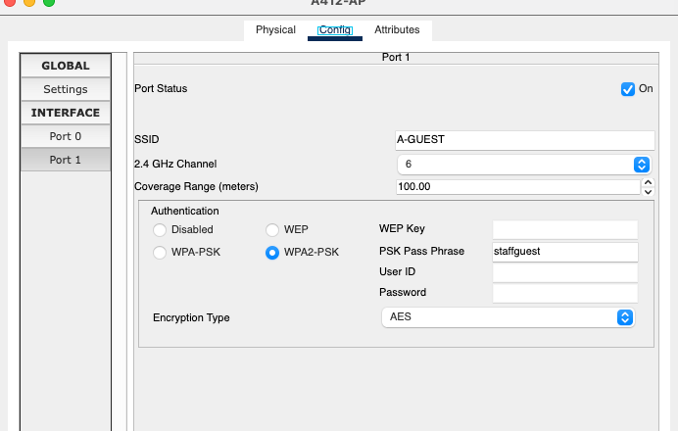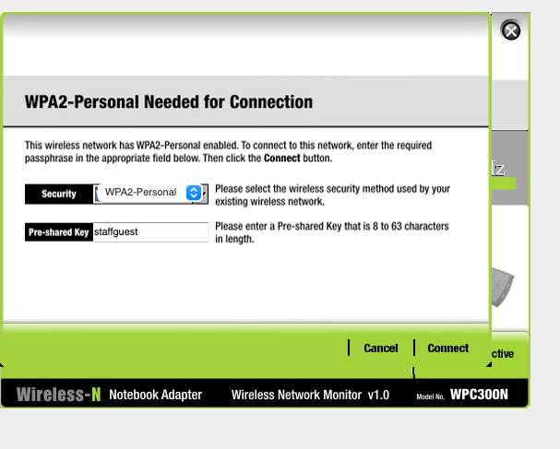

AP(config)#

**4. Addressing (4%)**

//DHCP

Router(config)#

//Static NAT

Router(config)#

MUST-Router(config)#ip nat inside source static 3.14.100.2 200.200.200.2

MUST-Router(config)#inte

MUST-Router(config)#interface g

MUST-Router(config)#interface f

MUST-Router(config)#interface fastEthernet 0/1

MUST-Router(config-if)#ip nat out

MUST-Router(config-if)#ip nat outside

MUST-Router(config-if)#ex

MUST-Router(config-if)#exit

MUST-Router(config)#int

MUST-Router(config)#interface f

MUST-Router(config)#interface fastEthernet 0/0

//Dynamic NAT

Router(config)#

Hospital-Router(config)#ip access-list stand

Hospital-Router(config)#ip access-list standard NAT

Hospital-Router(config)#ip access-list standard NAT-List

Hospital-Router(config-std-nacl)#permit 3.8.0.0 0.0.255.255

Hospital-Router(config-std-nacl)#ip nat pool NAT-Pool 200.200.200.5 200.200.200.6 netmas

Hospital-Router(config-std-nacl)#ip nat pool NAT-Pool 200.200.200.5 200.200.200.6 netmask 255.255.255.240

Hospital-Router(config)#ip nat inside source list NAT-List pool NAT-Pool overload

Hospital-Router#show ip access-lists

Extended IP access list NAT-List

10 deny ip 3.8.0.0 0.0.255.255 200.200.0.2 0.0.0.1

20 deny ip 3.8.0.0 0.0.255.255 host 200.200.0.4

40 deny ip 3.8.0.0 0.0.255.255 host 200.200.200.2

50 deny ip 3.8.0.0 0.0.255.255 host 200.200.200.3

60 permit ip 3.8.0.0 0.0.255.255 any

change to the extend NAT later...

MUST-Router(config)#ip access-list stan

MUST-Router(config)#ip access-list standard NAT

MUST-Router(config)#ip access-list standard NAT-List

MUST-Router(config-std-nacl)#permit 3.3.0.0 0.0.255.255

MUST-Router(config-std-nacl)#permit 3.1.0.0 0.0.255.255

MUST-Router(config-std-nacl)#permit 3.2.0.0 0.0.255.255

MUST-Router(config-std-nacl)#ip nat pool NAT-Pool 200.200.200.2 200.200.200.4 netmask 255.255.255.240

MUST-Router(config)#ip nat inside source list NAT-List pool NAT-Pool overload

HQI-Router(config)#ip access-list stan

HQI-Router(config)#ip access-list standard NAT-List

HQI-Router(config-std-nacl)#permit 3.27.0.0 0.0.255.255

HQI-Router(config-std-nacl)#ip nat pool NAT-Pool 100.100.100.2 100.100.100.2 netmask 255.255.255.252

HQI-Router(config)#ip nat pool NAT-Pool 100.100.100.2 100.100.100.2 netmask 255.255.255.252

HQI-Router(config)#ip nat inside source list NAT-List pool NAT-Pool overload

Hospital-Router#show ip nat translations

Pro Inside global Inside local Outside local Outside global

icmp 200.200.200.5:2 3.8.113.2:2 200.200.100.3:2 200.200.100.3:2

icmp 200.200.200.5:3 3.8.113.2:3 200.200.100.3:3 200.200.100.3:3

icmp 200.200.200.5:4 3.8.113.2:4 200.200.100.3:4 200.200.100.3:4

icmp 200.200.200.5:5 3.8.113.2:5 200.200.100.3:5 200.200.100.3:5

icmp 200.200.200.5:6 3.8.113.2:6 200.200.100.3:6 200.200.100.3:6

icmp 200.200.200.5:7 3.8.113.2:7 200.200.100.3:7 200.200.100.3:7

icmp 200.200.200.5:8 3.8.113.2:8 200.200.100.3:8 200.200.100.3:8

MUST-Router#show ip nat translations

Pro Inside global Inside local Outside local Outside global

icmp 200.200.200.2:2 3.14.100.2:2 200.200.100.3:2 200.200.100.3:2

icmp 200.200.200.2:3 3.14.100.2:3 200.200.100.3:3 200.200.100.3:3

icmp 200.200.200.2:4 3.14.100.2:4 200.200.100.3:4 200.200.100.3:4

1. **WAN (4%)**

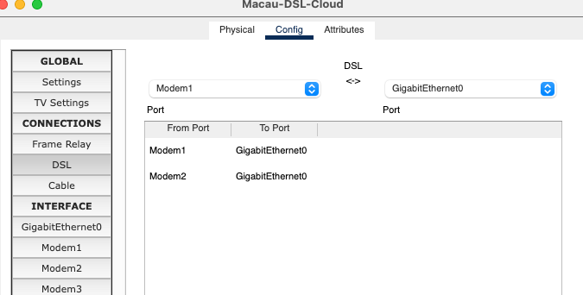

//DSL

Router(config)#  
MUST-Router(config)#interface fastEthernet 0/1

MUST-Router(config-if)#pppo

MUST-Router(config-if)#pppoe e

MUST-Router(config-if)#pppoe enable

MUST-Router(config-if)#

%LINK-5-CHANGED: Interface Virtual-Access1, changed state to up

%LINEPROTO-5-UPDOWN: Line protocol on Interface Virtual-Access1, changed state to up

MUST-Router(config-if)#no sh

MUST-Router(config-if)#no shutdown

MUST-Router(config-if)#exit

Macau-Router(config)#interface gigabitEthernet 0/0

Macau-Router(config-if)#ip add

Macau-Router(config-if)#pppoe en

Macau-Router(config-if)#pppoe enable

Macau-Router(config-if)#

%LINK-5-CHANGED: Interface Virtual-Access1, changed state to up

%LINEPROTO-5-UPDOWN: Line protocol on Interface Virtual-Access1, changed state to up

Macau-Router(config-if)#no sh

Macau-Router(config-if)#no shutdown

Hospital-Router(config)#interface fastEthernet 0/1

Hospital-Router(config-if)#pppoe en

Hospital-Router(config-if)#pppoe enable

Hospital-Router(config-if)#

%LINK-5-CHANGED: Interface Virtual-Access1, changed state to up

%LINEPROTO-5-UPDOWN: Line protocol on Interface Virtual-Access1, changed state to up

Hospital-Router(config-if)#no s

Hospital-Router(config-if)#no sh

Hospital-Router(config-if)#no shutdown

Macau-Router#show ip route

Codes: L - local, C - connected, S - static, R - RIP, M - mobile, B - BGP

D - EIGRP, EX - EIGRP external, O - OSPF, IA - OSPF inter area

N1 - OSPF NSSA external type 1, N2 - OSPF NSSA external type 2

E1 - OSPF external type 1, E2 - OSPF external type 2, E - EGP

i - IS-IS, L1 - IS-IS level-1, L2 - IS-IS level-2, ia - IS-IS inter area

* - candidate default, U - per-user static route, o - ODR

P - periodic downloaded static route

Gateway of last resort is not set

200.200.100.0/24 is variably subnetted, 2 subnets, 2 masks

C 200.200.100.0/29 is directly connected, GigabitEthernet0/0

L 200.200.100.3/32 is directly connected, GigabitEthernet0/0

200.200.200.0/32 is subnetted, 5 subnets

S 200.200.200.2/32 [1/0] via 200.200.100.2

S 200.200.200.3/32 [1/0] via 200.200.100.2

S 200.200.200.4/32 [1/0] via 200.200.100.2

S 200.200.200.5/32 [1/0] via 200.200.100.4

S 200.200.200.6/32 [1/0] via 200.200.100.4

//Frame Relay

Router(config)#

//Frame Relay

Router(config)#

MUST-Router(config)#interface Serial 0/0/0.1 multipoint

MUST-Router(config-subif)#

%LINK-5-CHANGED: Interface Serial0/0/0.1, changed state to up

%LINEPROTO-5-UPDOWN: Line protocol on Interface Serial0/0/0.1, changed state to up

MUST-Router(config-subif)#frame

MUST-Router(config-subif)#frame-relay interf

MUST-Router(config-subif)#frame-relay interface-dlci 333

MUST-Router(config-subif)#ip address 200.201.0.2 255.255.0.0

**6. Secure Tunnel (2%)**

//Site-to-site VPN

Router(config)#

~~//Remote-access VPN~~

**7. Access Control (4%)**

//ACL

Router(config)#

C400-Switch1(config)#ip access-list extended BLOCK-GUEST-TO-MUST

C400-Switch1(config-ext-nacl)#no permit ip any any

C400-Switch1(config-ext-nacl)#deny ip 3.3.89.0 0.0.0.255 host 3.8.113.2

C400-Switch1(config-ext-nacl)#permi

C400-Switch1(config-ext-nacl)#permit ip an

C400-Switch1(config-ext-nacl)#permit ip any any

C400-Switch1(config-ext-nacl)#ex

C400-Switch1(config-ext-nacl)#exit

C400-Switch1(config)#

C400-Switch1(config)#ex

C400-Switch1(config)#exit

C400-Switch1#

%SYS-5-CONFIG_I: Configured from console by console

C400-Switch1#show ip ac

C400-Switch1#show ip access-lists

Extended IP access list BLOCK-GUEST-TO-MUST

10 deny ip 3.3.89.0 0.0.0.255 3.14.100.0 0.0.0.255 (4 match(es))

20 deny ip 3.3.89.0 0.0.0.255 host 3.8.113.2 (4 match(es))

30 permit ip any any

MUST-Router#show ip access-lists

Extended IP access list VPN-ALLOW-LIST

Extended IP access list NAT-List

10 deny ip 3.2.88.0 0.0.0.255 host 3.27.55.2 (8 match(es))

20 deny ip 3.3.89.0 0.0.0.255 host 3.27.55.2 (8 match(es))

30 deny ip host 3.1.10.3 host 3.27.55.2 (4 match(es))

50 permit icmp 3.3.23.0 0.0.0.127 host 3.27.55.2 (8 match(es))

60 permit tcp 3.3.23.0 0.0.0.127 host 3.27.55.2 eq www (6 match(es))

70 permit tcp 3.3.23.0 0.0.0.127 host 3.27.55.2 eq 443 (4 match(es))

73 deny tcp 3.3.23.0 0.0.0.127 host 3.27.55.2 eq ftp

75 deny ip 3.3.23.0 0.0.0.127 host 3.27.55.2

80 permit ip 3.1.0.0 0.0.255.255 any

90 permit ip 3.2.0.0 0.0.255.255 any

100 permit ip 3.3.0.0 0.0.255.255 any (20 match(es))

110 permit ip 3.14.0.0 0.0.255.255 any

1. **Other (0%)**





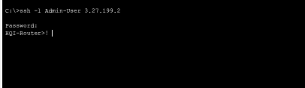

AAA

Router(config)#  
  
Hospital-Router(config)#ip ssh version 2

Please create RSA keys (of at least 768 bits size) to enable SSH v2.

Hospital-Router(config)#

Hospital-Router(config)#

Hospital-Router(config)#ip do

Hospital-Router(config)#ip dom

Hospital-Router(config)#ip domain-name hospital.must.edu.mo

Hospital-Router(config)#crypto key genera

Hospital-Router(config)#crypto key generate rsa

The name for the keys will be: Hospital-Router.hospital.must.edu.mo

Choose the size of the key modulus in the range of 360 to 2048 for your

General Purpose Keys. Choosing a key modulus greater than 512 may take

a few minutes.

How many bits in the modulus [512]: 1024

% Generating 1024 bit RSA keys, keys will be non-exportable...[OK]

Hospital-Router(config)#ip ssh time-out 60

*Mar 4 14:25:26.517: %SSH-5-ENABLED: SSH 2 has been enabled

Hospital-Router(config)#ip ssh au

Hospital-Router(config)#ip ssh authentication-retries 3

Hospital-Router(config)#

Hospital-Router(config)#line vt

Hospital-Router(config)#line vty 0 4

Hospital-Router(config-line)#tra

Hospital-Router(config-line)#transport in

Hospital-Router(config-line)#transport input ssh

Hospital-Router(config-line)#no pass

Hospital-Router(config-line)#no password

Hospital-Router(config-line)#ex

Hospital-Router(config-line)#ex

% Ambiguous command: "ex"

Hospital-Router(config-line)#exit

Hospital-Router(config)#aaa new-m

Hospital-Router(config)#aaa new-model

Hospital-Router(config)#radius-server host 3.8.113.2 key 3.8.113.2

Hospital-Router(config)#aaa au

Hospital-Router(config)#aaa auth

Hospital-Router(config)#aaa authen

Hospital-Router(config)#aaa authentication log

Hospital-Router(config)#aaa authentication login SSH

Hospital-Router(config)#aaa authentication login SSH-LOGIN group radius

Hospital-Router(config)#line vty 0 4

Hospital-Router(config-line)#login auth

Hospital-Router(config-line)#login authentication SSH-LOGIN